21.86: a) On the x-axis: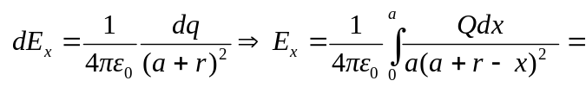
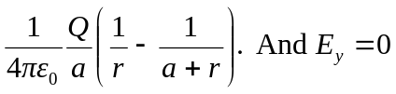.
b)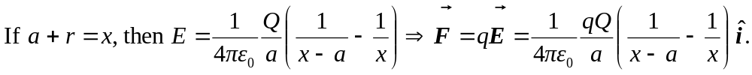
c)
from far away.

